STACKOVERFLOW APP

STUDENT: TEODORA TAT
GROUP: 30433

Contents
- Introduction
- Technologies used
- Use case diagram
- Architecture
- Package diagram
- Class diagram
- Database diagram
- Endpoints requests
- Architecture of the Frontend
- Routing

- Introduction
The StackOverflow project aims to create a simplified version of the popular Q&A platform. In this system, users can ask questions, provide answers, and engage in voting on questions and answers. The project will initially have a single type of user, with the possibility of implementing additional roles as a bonus feature. Security measures are in place to ensure that only logged-in users can perform actions, and passwords are stored in an encrypted format.
The key features of the StackOverflow project include the ability for users to ask questions, which include various details such as the author, title, text, creation date & time, picture, and tags. Users can also search and filter questions based on tags, text, or users. The system supports the sorting of questions by creation date, with the most recent ones appearing first. Users have the privilege to edit or delete their own questions.
Additionally, users can answer questions, providing their own insights and solutions. Each answer includes details such as the author, text, picture, and creation date & time. Answer authors have the ability to edit or delete their answers. When viewing a question individually, all associated answers are displayed.
Voting plays a significant role in the system, allowing users to express their opinion on questions and answers. Users can upvote or downvote questions and answers, with the vote count displayed for each item. Answers are sorted based on their vote count, with the most highly voted answers appearing first.
As a bonus feature, the project includes a scoring system to evaluate user participation. Users earn points when their questions or answers receive upvotes, and lose points when they receive downvotes or downvote other users' answers. The user's score is displayed alongside their name for each question and answer.
Furthermore, the project provides the option to have moderators, who possess special privileges. Moderators can remove inappropriate content, edit any question or answer, and ban users for misconduct. Banned users receive notifications via email, and are restricted from accessing the application.
To meet the technical requirements, the project employs a layered architecture and follows object-oriented programming (OOP) concepts. Data is stored in a relational or non-relational database, and thorough documentation accompanies the project.
The deliverables include source code hosted on a version control system, a SQL script for database generation and population with test data, and comprehensive documentation. The project will be assessed based on functionality, entity mapping, CRUD operations for users, questions, and answers, adherence to architectural principles, database design, testing, code quality, and documentation.
The StackOverflow project provides a platform for users to ask questions, receive answers, and engage in a vibrant community. It fosters knowledge sharing and collaboration while ensuring a secure and efficient user experience.
- Technologies used
The StackOverflow project leverages a combination of technologies to create a robust and efficient system. The key technologies used in this project include:

- Backend: Java Spring Boot:
Java Spring Boot is a popular framework for building Java-based web applications. It provides a powerful set of features and tools that simplify the development process. In the StackOverflow project, Spring Boot is used on the backend to handle server-side logic, data management, and API integration.
- Frontend: Angular:
Angular is a widely used JavaScript framework for building dynamic web applications. It enables the creation of responsive and interactive user interfaces. In the StackOverflow project, Angular is employed on the frontend to design and develop the user interface, handle user interactions, and communicate with the backend APIs.
- Database: MySQL:
MySQL is a relational database management system that offers scalability, reliability, and robustness. It provides efficient data storage and retrieval capabilities, making it an ideal choice for applications with structured data requirements. In the StackOverflow project, MySQL is utilized to store and manage user data, questions, answers, and other relevant information.
By combining these technologies, the StackOverflow project takes advantage of the strengths of each component. Java Spring Boot provides a solid foundation for backend development, allowing for efficient data processing and business logic implementation. Angular, on the other hand, enables the creation of a modern and intuitive user interface, enhancing the user experience and facilitating seamless interactions with the backend services. The integration with MySQL ensures reliable and secure data storage, enabling efficient querying and retrieval of information.
Overall, the combination of Java Spring Boot, Angular, and MySQL forms a robust and scalable technology stack that empowers the StackOverflow project to deliver a feature-rich and user-friendly Q&A platform.

- Use Case Diagram
A use case diagram is a visual representation of the interactions between users (actors) and a system. It illustrates the different use cases or functionalities of the system and the actors involved in each use case. Use case diagrams help to identify and understand the various features and interactions of a system from a user's perspective.
Here is an example of a use case diagram for the StackOverflow application:
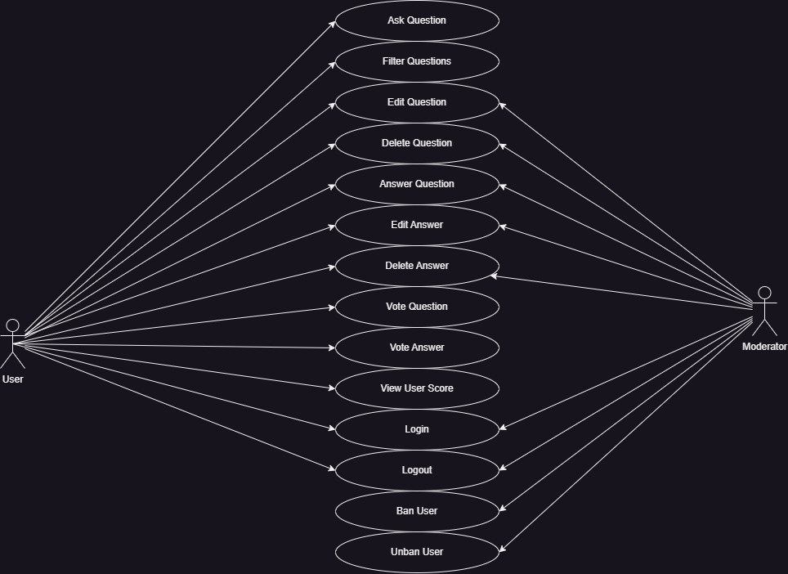

Overall, the use case diagram provides a high-level overview of the various functionalities and interactions of the StackOverflow application, helping to understand the system's behavior from a user's perspective.

- Architecture
The architecture of the project can follow a layered approach, consisting of the following components: Model/Entities, Repository, Service, and Controller.
- Model/Entities:
- This layer represents the data model of the application and defines the entities that will be persisted in the database.
- Each entity corresponds to a table in the database and contains the attributes and relationships required for the application.
- The entities for the StackOverflow project include User, Content, Tag, Vote.
- Repository:
- The repository layer is responsible for interacting with the database and performing CRUD (Create, Read, Update, Delete) operations on the entities.
- It provides an abstraction over the database access and allows the service layer to work with the entities without directly dealing with the database operations.
- The repository layer typically uses an Object-Relational Mapping (ORM) framework, such as Hibernate, to handle the database operations.
- Service:
- The service layer contains the business logic of the application.
- It provides services that encapsulate the operations and rules related to the application's functionality.
- The service layer communicates with the repository layer to fetch and store data, perform validations, and apply business rules.
- Example services for the StackOverflow project: UserService, QuestionService, AnswerService, etc.
- Controller:
- The controller layer handles the incoming HTTP requests and maps them to appropriate service methods.
- It acts as an interface between the client (e.g., web browser, mobile app) and the application's services.
- The controller receives the request, validates the input, invokes the corresponding service methods, and returns the HTTP response.
- Example controllers for the StackOverflow project could include UserController, QuestionController, AnswerController, etc.
- Endpoints:
- Each controller exposes a set of endpoints that define the API for the application.
- These endpoints are responsible for handling specific HTTP requests and returning the appropriate responses.
- Examples of endpoints for the StackOverflow project could include:
- GET /users: Retrieve a list of users.
- POST /users: Create a new user.
- GET /questions: Retrieve a list of questions.
- POST /questions: Create a new question.
- PUT /questions/{questionId}: Update a question.
- DELETE /questions/{questionId}: Delete a question.
- GET /answers: Retrieve a list of answers.
- POST /answers: Create a new answer.
- PUT /answers/{answerId}: Update an answer.
- DELETE /answers/{answerId}: Delete an answer.
By following this layered architecture approach, the project separates concerns, improves maintainability, and allows for easier testing and scalability. The entities encapsulate the data, the repository handles data access, the service layer implements the business logic, and the controller layer provides the API endpoints for client interaction.

- Package diagram
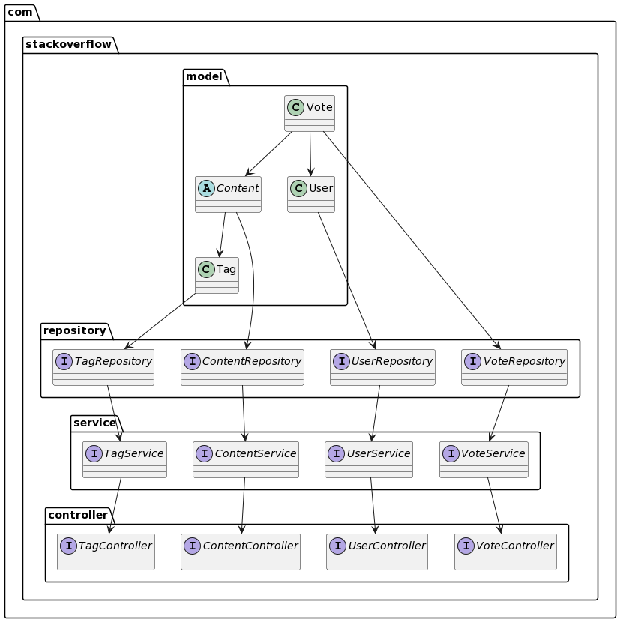

User:
- Represents a user in the system.
- It is associated with the UserRepository, which handles the persistence and retrieval of user data.
- It is connected to the Vote entity, indicating that a user can vote on content.
- It is associated with the UserService, which provides operations related to user management.
Content:

- Represents a generic content in the system, which includes questions and answers.
- It is the parent class for more specific content types.
- It is associated with the ContentRepository, responsible for storing and retrieving content data.
- It is connected to the Tag entity, as content can be associated with one or more tags.
- It is connected to the User entity, indicating the author of the content.
- It is connected to the Vote entity, as users can vote on content.
- It is associated with the ContentService, which handles content-related operations.
Tag:
- Represents a tag associated with content.
- It is associated with the TagRepository, responsible for managing tags in the system.
- It is connected to the Content entity, as content can be associated with one or more tags.
- It is associated with the TagService, which provides operations related to tag management.
Vote:
- Represents a vote given by a user on content.
- It is associated with the VoteRepository, which handles the persistence and retrieval of vote data.
- It is connected to the User entity, indicating the user who cast the vote.
- It is connected to the Content entity, indicating the content on which the vote is cast.
- It is associated with the VoteService, which provides operations related to voting.
These entities are part of the overall package structure of the StackOverflow project, which includes the model package for entities, repository package for repositories, service package for services, and controller package for controllers. The arrows in the diagram indicate the dependencies and associations between these packages and entities, showcasing the flow of data and operations within the system.
- Class diagram
Model Package:
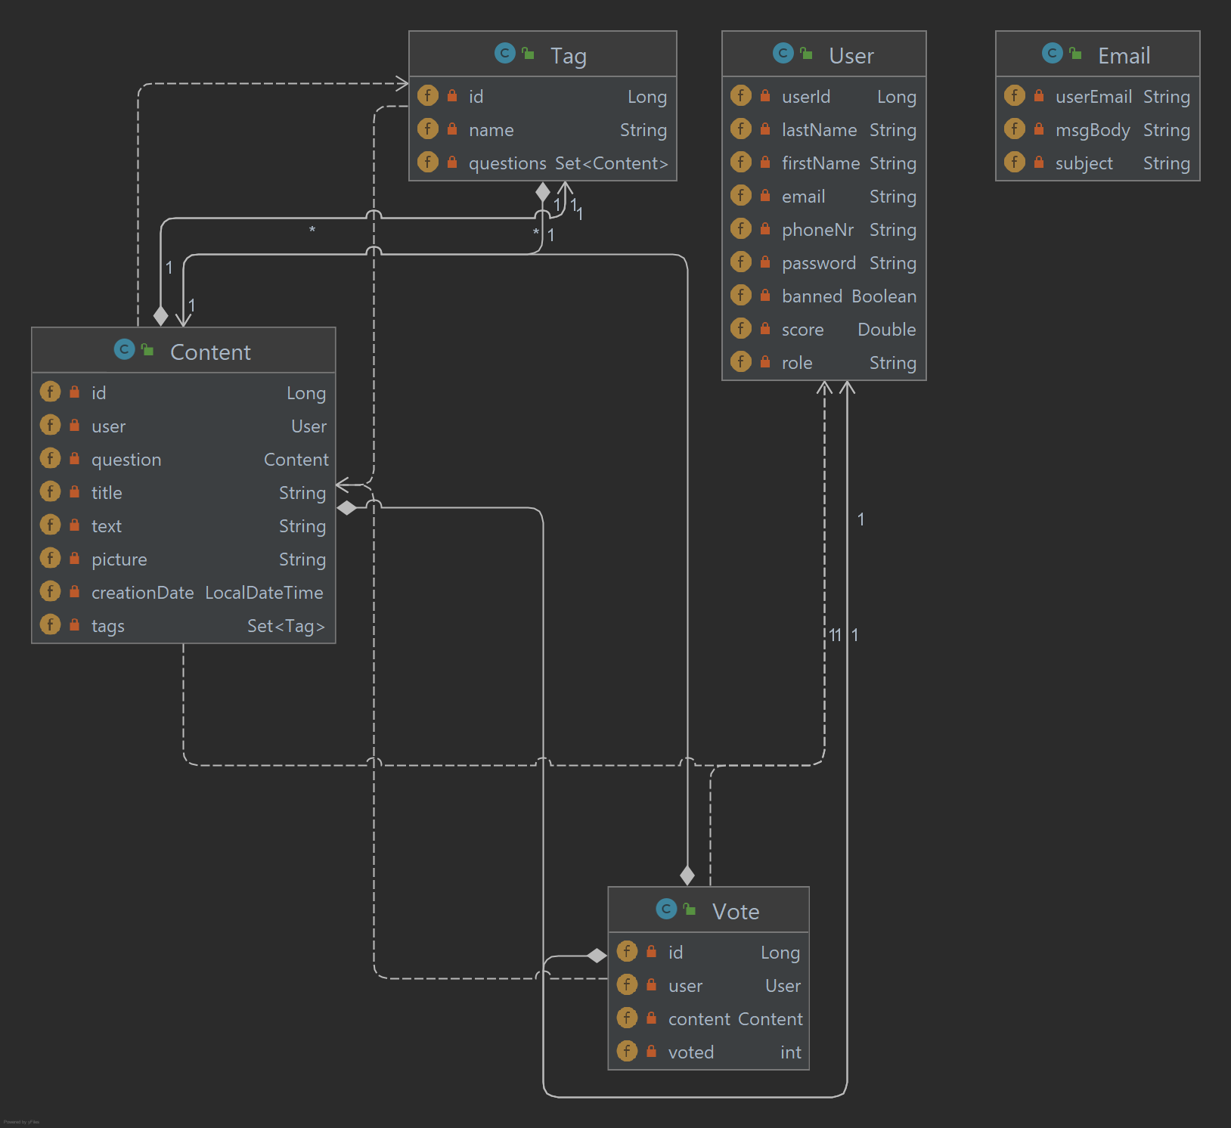
Entities:
- Content:
- Represents a piece of content in the Stack Overflow system, which can include questions, answers, or other types of content.
- It has properties such as id, user (the author of the content), question (if it is an answer to a question), title, text, picture, and creationDate.
- It is associated with the User entity through a many-to-one relationship, indicating the author of the content.
- It is associated with the Tag entity through a many-to-many relationship, indicating the tags associated with the content.
- It is connected to the Question entity through a many-to-one relationship, indicating that it can be a question or an answer to a question.
- It is connected to the ContentRepository for persistence and retrieval of content data.
- Tag:
- Represents a tag associated with content in the Stack Overflow system.
- It has properties such as id and name.
- It is associated with the Content entity through a many-to-many relationship, indicating the content that is tagged with this tag.
- It is connected to the TagRepository for managing tag data.
- User:
- Represents a user in the Stack Overflow system.
- It has properties such as userId, lastName, firstName, email, phoneNr, password, banned, score, and role.
- It is connected to the Content entity through a many-to-one relationship, indicating the content authored by the user.
- It is connected to the Vote entity through a one-to-many relationship, indicating the votes cast by the user.
- It is connected to the UserRepository for persistence and retrieval of user data.
- Vote:
- Represents a vote given by a user on a piece of content in the Stack Overflow system.
- It has properties such as id, user (the user who cast the vote), content (the content on which the vote is cast), and voted (the value of the vote).
- It is associated with the User entity through a many-to-one relationship, indicating the user who cast the vote.
- It is associated with the Content entity through a many-to-one relationship, indicating the content on which the vote is cast.
- It is connected to the VoteRepository for persistence and retrieval of vote data.
These entities are part of the com.utcn.stack_overflow.entity package and are used to represent and manage the data in the Stack Overflow system.
All Classes diagram:
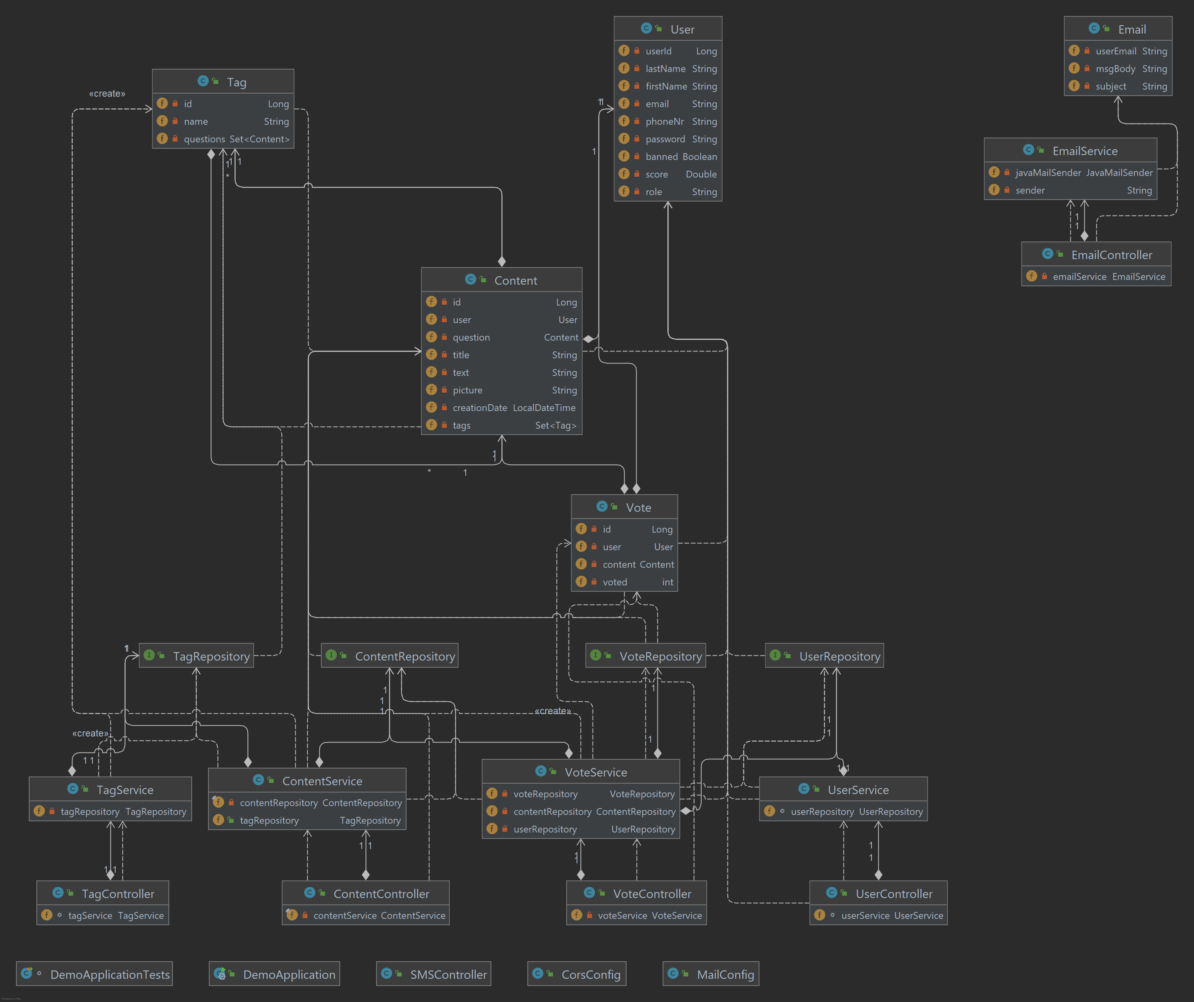

- Database diagram
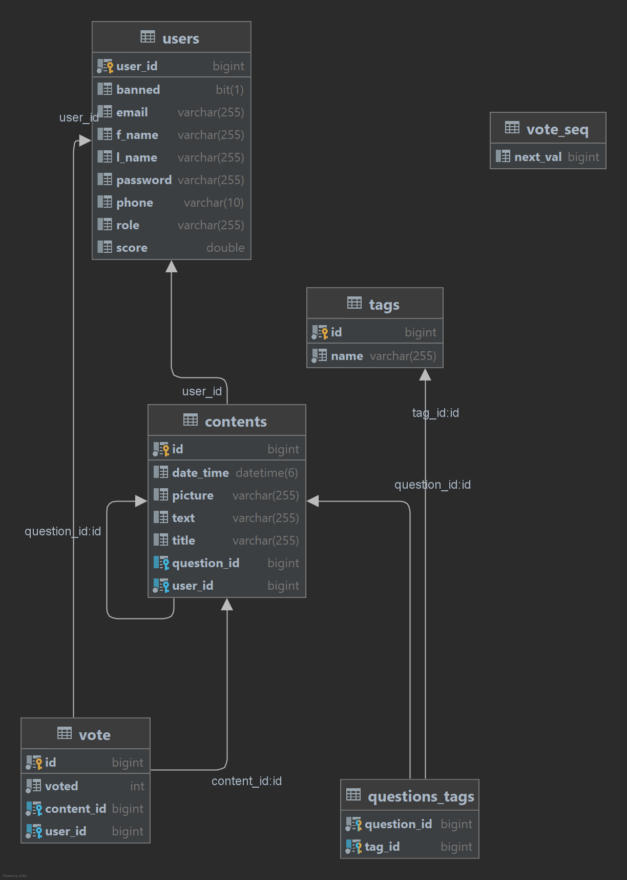
Content:
- Many-to-One relationship with User: The user_id column in the contents table is a foreign key referencing the primary key (user_id) in the users table.
- Many-to-One relationship with Content (self-relationship): The question_id column in the contents table is a foreign key referencing the primary key (id) in the same contents table.
- Many-to-Many relationship with Tag: A join table named questions_tags is created to represent the many-to-many relationship between contents and tags. It consists of two columns: question_id (foreign key referencing contents.id) and tag_id (foreign key referencing tags.id).
Tag:
- Many-to-Many relationship with Content: The many-to-many relationship between tags and contents is established through the questions_tags join table. It consists of two columns: tag_id (foreign key referencing tags.id) and question_id (foreign key referencing contents.id).
User:
- One-to-Many relationship with Content: The user_id column in the contents table is a foreign key referencing the primary key (user_id) in the users table.
- One-to-Many relationship with Vote: The user_id column in the vote table is a foreign key referencing the primary key (user_id) in the users table.
Vote:
- Many-to-One relationship with User: The user_id column in the vote table is a foreign key referencing the primary key (user_id) in the users table.
- Many-to-One relationship with Content: The content_id column in the vote table is a foreign key referencing the primary key (id) in the contents table.

- Endpoints request

- ContentController.getAllContents()
- Endpoint: GET /contents/getAll
- Input: No input parameters
- Output: Returns a ResponseEntity with a list of Content objects (List<Content>)
- ContentController.getAllQuestions()
- Endpoint: GET /contents/getAllQuestions
- Input: No input parameters
- Output: Returns a ResponseEntity with a list of Content objects representing questions (List<Content>)
- ContentController.getAllAnswers(Long questionId)
- Endpoint: GET /contents/getAllAnswers?questionId={questionId}
- Input: The questionId as a query parameter
- Output: Returns a ResponseEntity with a list of Content objects representing answers to the specified question (List<Content>)
- ContentController.getAllQuestionsByTitle(String title)
- Endpoint: GET /contents/getAllQuestionsByTitle?title={title}
- Input: The title as a query parameter
- Output: Returns a ResponseEntity with a list of Content objects representing questions with the specified title (List<Content>)
- ContentController.getAllQuestionsByTag(String tagNames)
- Endpoint: GET /contents/getAllQuestionsByTag?tagNames={tagNames}
- Input: The tagNames as a query parameter
- Output: Returns a ResponseEntity with a list of Content objects representing questions associated with the specified tags (List<Content>)
- ContentController:
GET /contents/getAllQuestionsByUser?userEmail={userEmail}:
Input: The userEmail as a query parameter
Output: Returns a ResponseEntity with a list of Content objects representing questions posted by the specified user.
GET /contents/getById/{id}:
Input: The id as a path variable
Output: Returns a ResponseEntity with a Content object that matches the specified ID, if found. Otherwise, returns ResponseEntity.notFound().
POST /contents/insertContent:
Input: Expects a Content object in the request body
Output: Returns a ResponseEntity with the created Content object in the response body, with the status code HttpStatus.CREATED.
POST /contents/insertQuestion:
Input: Expects a Content object in the request body
Output: Returns the created Content object.
POST /contents/insertAnswer/{questionId}:
Input: Expects a Content object in the request body and the questionId as a path variable
Output: Returns a ResponseEntity with the created Content object representing the answer, if the associated question is found. Otherwise, returns ResponseEntity.notFound().
PUT /contents/{id}:
Input: The id as a path variable and a Content object in the request body
Output: Updates the question with the specified ID with the provided content.
PUT /contents/updateContent/{id}:

Input: The id as a path variable and a Content object in the request body
Output: Returns a ResponseEntity with the updated Content object, if found. Otherwise, returns ResponseEntity.notFound().
DELETE /contents/deleteById/{id}:
Input: The id as a path variable
Output: Deletes the content with the specified ID and returns ResponseEntity.noContent().
POST /contents/content/addTags/{contentId}/tag/{tagNames}:
Input: The contentId as a path variable and a set of tagNames as a path variable
Output: Adds the specified tags to the content with the given ID.
GET /contents/getId?text={text}:
Input: The text as a query parameter
Output: Returns a Content object that matches the specified text, if found.
- UserController:
GET /users/getAll:
Input: No input parameters
Output: Returns a list of User objects.
GET /users/getById/{cnp}:
Input: The cnp as a path variable
Output: Returns a User object that matches the specified CNP (personal identification number), if found.
GET /users/getByEmail{email}:
Input: The email as a query parameter
Output: Returns a User object that matches the specified email, if found.
GET /users/login:
Input: The email and password as query parameters
Output: Returns a ResponseEntity with the User object if the email and password match, otherwise returns ResponseEntity.notFound().
GET /users/getAllUsers:
Input: No input parameters
Output: Returns a list of User objects representing non-moderator users.
DELETE /users/deleteById/{cnp}:
Input: The cnp as a path variable
Output: Deletes the user with the specified CNP and returns a message string.
POST /users/insertUser:
Input: Expects a User object in the request body
Output: Returns the created User object.
PUT /users/updateUser:
Input: Expects a User object in the request body
Output: Returns the updated User object.
PUT /users/ban/{email}:
Input: The email as a path variable
Output: Bans the user with the specified email.
PUT /users/unban/{email}:
Input: The email as a path variable
Output: Unbans the user with the specified email.
PUT /users/ban1/{userId}:
Input: The userId as a query parameter
Output: Bans the user with the specified ID.
- VoteController:
POST /vote/like/{userId}/{contentId}:
Input: The userId and contentId as path variables
Output: Returns a message string indicating the success of the operation.
POST /vote/dislike/{userId}/{contentId}:
Input: The userId and contentId as path variables
Output: Returns a Vote object representing the dislike operation.
GET /vote/hasVoted/{userId}/{contentId}:
Input: The userId and contentId as path variables
Output: Returns a boolean value indicating whether the user has voted for the content.
DELETE /vote/removeVote/{userId}/{contentId}:
Input: The userId and contentId as path variables
Output: Removes the vote of the user for the content.
GET /vote/computeVoteCount/{contentId}:
Input: The contentId as a path variable
Output: Returns the vote count for the specified content.
GET /vote/getAll:
Input: No input parameters
Output: Returns a list of all Vote objects.

